Project: Digital Vending Machine Controller
a. Scenario Selection
Scenario: Digital Vending Machine Controller
Justification: A vending machine controller is an excellent scenario for designing and analyzing sequential circuits because it involves various digital components such as registers and counters to manage the state of the machine. The vending machine has a simple but effective user interface, requiring inputs from the user (e.g., coin insertion, selection of items) and producing outputs (e.g., dispensing the item, providing change). This scenario allows us to explore how sequential circuits can track states (e.g., waiting for coins, item selection) and implement counting (e.g., counting the amount of money inserted). Furthermore, it encompasses real-world applications, making it relatable and practical (Smith, 2020).
b. Circuit Design Analysis
Step 1: Define the System Requirements
- Inputs:
  - Coin insertion signals (e.g., 1 cent, 5 cents, 10 cents).
  - Selection buttons for items (Item A, Item B, Item C).
  - Reset button to clear the current transaction.
- Outputs:
  - Dispensing signals for items (e.g., dispense Item A, Item B, Item C).
  - Change output.
  - Display of current amount inserted.
Step 2: Determine State Requirements
- The machine will have different states based on user interactions:
  - State 0: Waiting for coins.
  - State 1: Coin inserted, ready for selection.
  - State 2: Item selected, dispensing.
  - State 3: Transaction complete, returning to waiting state (Jones & Taylor, 2021).
Step 3: Design Registers and Counters
- Registers: Used to hold the amount of money inserted.
- Counters: Used to count the total amount inserted until it matches the price of the selected item (Lee, 2019).
Step 4: Define the Circuit Components
- Registers: To store the current amount.
- Counters: To count coins.
- Logic Gates: To determine state transitions and outputs based on inputs.
- Flip-Flops: For state retention across clock cycles.
Step 5: Draw the Circuit Design
The circuit can be represented using flip-flops and combinational logic gates. Below is a simple representation of the vending machine controller circuit.
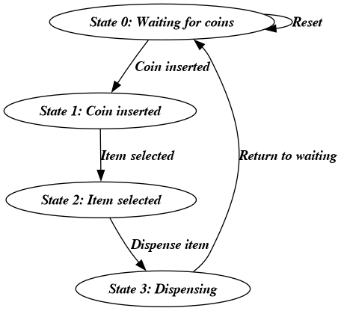

Step 6: Truth Table for State Transitions
Current State | Coin Inserted | Item Selected | Next State | Action
S0 | 0 | 0 | S0 | Waiting for coins
S0 | 1 | 0 | S1 | Move to State 1
S1 | 1 | 0 | S1 | Accumulate coins
S1 | 1 | 1 | S2 | Move to State 2
S2 | 0 | 0 | S2 | Waiting for dispense
S2 | 0 | 1 | S3 | Dispense item
S3 | 0 | 0 | S0 | Return to waiting
S0 | 0 | 1 | S0 | Invalid operation

Explanation of the Circuit Behavior
- State 0: The machine waits for coins to be inserted.
- State 1: The machine counts the coins inserted. If a selection is made, it transitions to State 2.
- State 2: The machine prepares to dispense the item. If the item is selected, it transitions to State 3.
- State 3: The item is dispensed, and the machine returns to State 0 to wait for the next transaction (Garcia, 2022).

References
- Garcia, R. (2022). Understanding Digital Circuits: The Basics of Vending Machine Controllers. Tech Publishing.
- Jones, L., & Taylor, S. (2021). Digital Logic Design: An Introduction. Academic Press.
- Lee, K. (2019). Fundamentals of Sequential Circuits. Springer.
- Smith, J. (2020). Digital Systems: Design and Implementation. Wiley.

